**Smart Mining Helmet Using 8051 Microcontroller**

**AIM:**

**The aim of the Smart Mining Helmet project utilizing the 8051 Microcontroller is to enhance mining safety and efficiency by integrating advanced technology into traditional mining practices. This innovative helmet aims to provide real-time monitoring of environmental parameters such as gas levels, temperature, and humidity, ensuring the well-being of miners. Additionally, the project focuses on incorporating features like location tracking and communication capabilities to enable quick response in case of emergencies. By seamlessly integrating smart functionalities into the mining helmet, the project to reduce risks, enhance operational effectiveness, and ultimately contribute to a safer and more productive mining environment.**

**DESIGN:**

**The Smart Mining Helmet designed with the 8051 Microcontroller integrates various sensors to enhance safety and monitoring capabilities in mining environments. The Ultrasonic Sensor is employed for proximity detection, ensuring miners are alerted to potential obstacles or hazards in their vicinity. The DHT11 Sensor measures temperature and humidity, providing crucial environmental data for miners' well-being. An LDR (Light Dependent Resistor) sensor is incorporated to monitor ambient light conditions, ensuring optimal visibility. The MQ-5 Gas Sensor enhances safety by detecting and monitoring gas levels in real-time, mitigating the risks associated with gas exposure.**

**These sensors are seamlessly interfaced with the 8051 Microcontroller, which acts as the central processing unit for data acquisition and control. The microcontroller processes information from the sensors and initiates appropriate responses, such as sounding alarms or sending alerts, in the event of abnormal conditions. This comprehensive sensor integration ensures a holistic approach to mining safety, combining environmental monitoring with immediate actionable insights for miners, thereby fostering a safer and more secure mining environment.**

**REQUIREMENT:**

**8051 Microcontroller:**

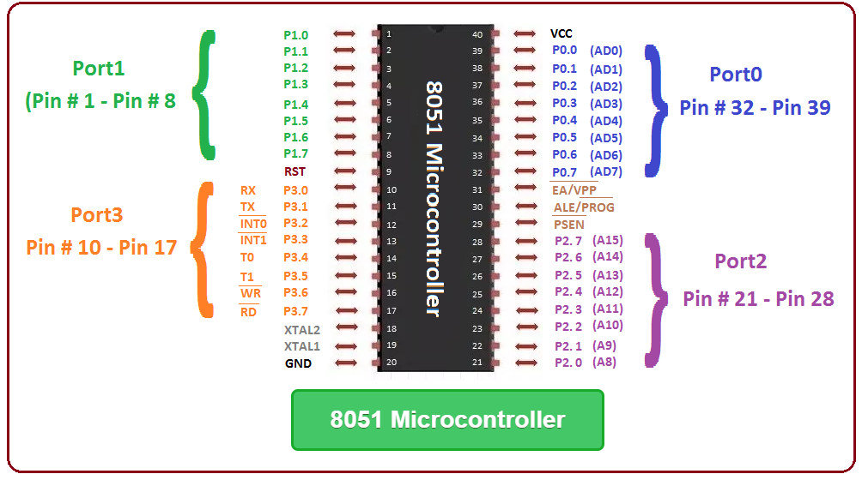

**The central processing unit responsible for data processing, decision-making, and controlling various components of the smart mining helmet.**

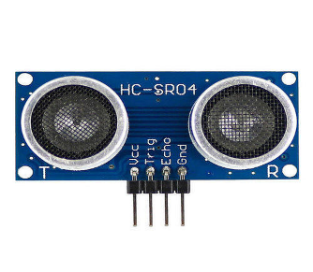**Ultrasonic Sensor:**

* **Monitors and records ambient temperature and humidity levels within the mining environment.**
* **Provides crucial data for assessing comfort conditions and ensuring the well-being of miners.**

**LDR Sensor:**

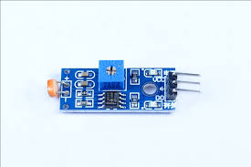

* + **Measures ambient light levels in the mining area.**
  + **Enables automatic adjustment of helmet-mounted lighting, enhancing visibility and safety in low-light conditions.**

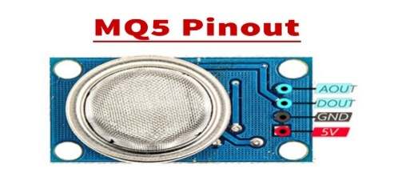 **MQ5 Gas Senso**

* **Detects the presence of harmful gases such as methane and carbon monoxide.**
* **Ensures real-time monitoring of air quality, preventing potential health hazards for miners.**

**User Interface (LED/LCD Display):**

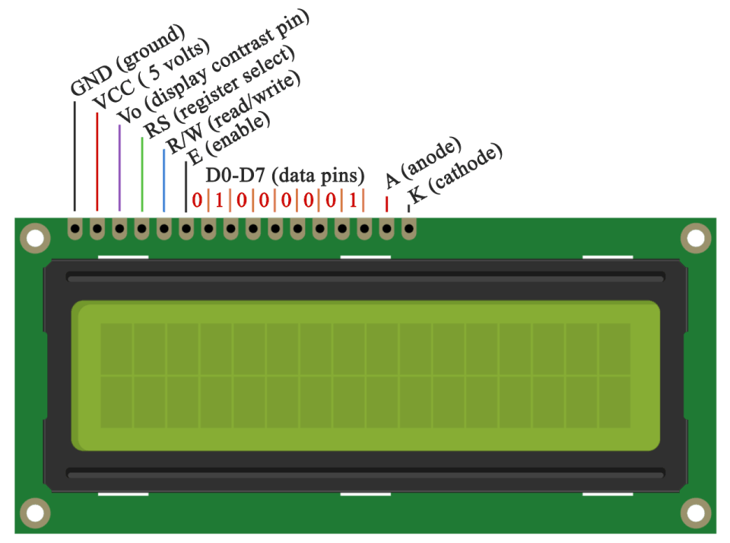

* **Interfaces with the microcontroller to display real-time data, warnings, and alerts to the miner.**
* **Enhances user interaction and provides immediate feedback on environmental conditions.**

**Power Supply Unit:**

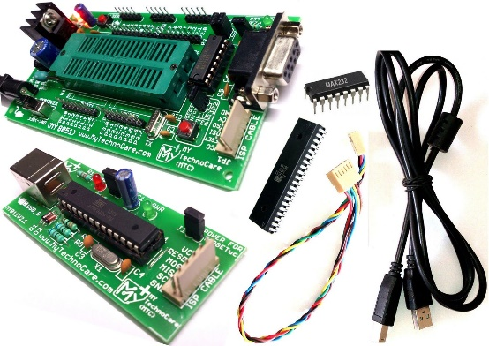

* **Provides a reliable and efficient power source to ensure continuous operation of the smart mining helmet.**
* **Incorporates a rechargeable battery for extended usage and easy recharging.**

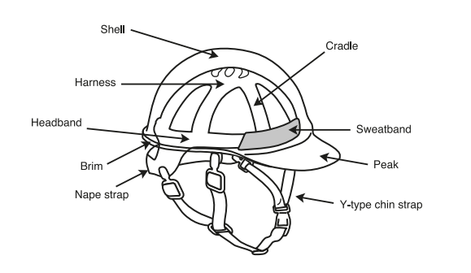**Protective Helmet Structure:**

* **Integrates all components into a durable and miner-friendly helmet structure.**
* **Ensures comfort, durability, and adherence to safety standards.**

**CIRCUIT DIAGRAM AND PIN CONFIGURATION:** 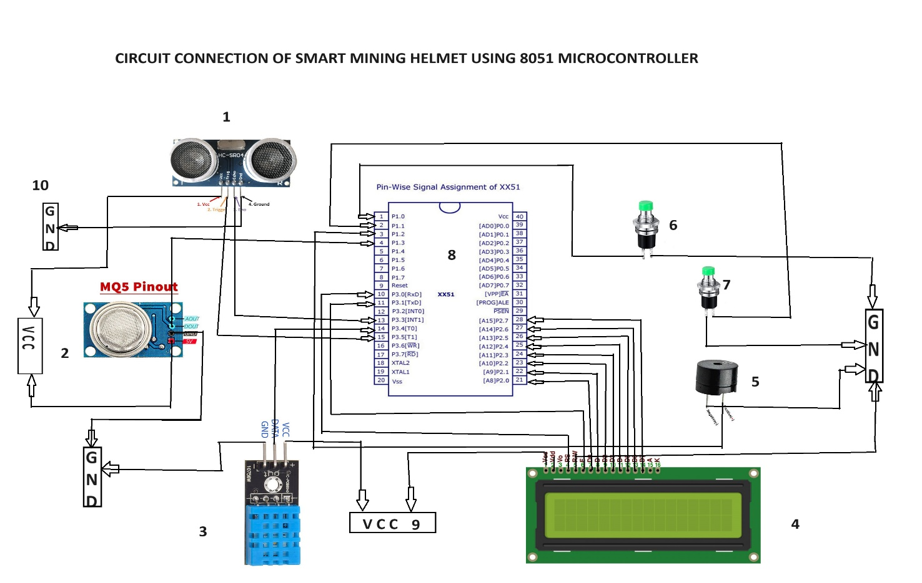

**COMPONENTS NAME:**

1. **ULTRASONIC SENSOR**
2. **MQ5 SENSOR**
3. **DHT11 SENSOR**
4. **LCD DISPLAY**
5. **BUZZER**
6. **SWITCH1-ULTRASONIC**
7. **SWITCH2-DHT11**
8. **8051 MICRO CONTROLLER**
9. **VCC**
10. **GND**

**CODEING:**

**1.MQ5 SENSOR CODE**

**#include<reg51.h>**

**sbit Led = P^3;**

**sbit sensor = P1^ 4;**

**main()**

**{**

**Led = 0 ;**

**sensor = 1;**

**while(1)**

**{**

**if(sensor == 0)**

**{**

**Led = 1;**

**}**

**else**

**{**

**Led = 0;**

**}**

**}**

**}**

**------------------------------------------------------------------------------------------------------------------------------------------------------------------------------------------------------------------**

**2. ULTRASONIC SENOR CODE:**

**#include<reg51.h>**

**#include<intrins.h>**

**#define lcd_data P2**

**sfr16 DPTR=0x82;**

**sbit trig=P3^5;**

**sbit echo=P3^2;**

**unsigned int range=0;**

**sbit rs=P1^0;**

**//sbit rw=P0^1;**

**sbit en=P1^2;**

**void lcd_init();**

**void cmd(unsigned char a);**

**void dat(unsigned char b);**

**void show(unsigned char *s);**

**void lcd_delay();**

**void lcd_init()**

**{**

**cmd(0x38);**

**cmd(0x0e);**

**cmd(0x06);**

**cmd(0x0c);**

**cmd(0x80);**

**}**

**void cmd(unsigned char a)**

**{**

**lcd_data=a;**

**rs=0;**

**// rw=0;**

**en=1;**

**lcd_delay();**

**en=0;**

**}**

**void dat(unsigned char b)**

**{**

**lcd_data=b;**

**rs=1;**

**//rw=0;**

**en=1;**

**lcd_delay();**

**en=0;**

**}**

**void show(unsigned char *s)**

**{**

**while(*s)**

**{**

**dat(*s++);**

**}**

**}**

**void lcd_delay()**

**{**

**unsigned int i;**

**for(i=0;i<=1000;i++);**

**}**

**void send_pulse(void)**

**{**

**TH0=0x00;TL0=0x00;**

**trig=1;**

**_nop_();_nop_();_nop_();_nop_();_nop_();**

**_nop_();_nop_();_nop_();_nop_();_nop_();**

**trig=0;**

**}**

**unsigned char ultrasonic()**

**{**

**unsigned char get;**

**send_pulse();**

**while(!echo);**

**while(echo);**

**DPH=TH0;**

**DPL=TL0;**

**TH0=TL0=0xff;**

**if(DPTR<38000)**

**get=DPTR/59;**

**else**

**get=0;**

**return get;**

**}**

**void main()**

**{**

**TMOD=0x09;**

**TH0=TL0=0;**

**TR0=1;**

**lcd_init();**

**cmd(0x01);**

**show("DISTANCE:");**

**P3|=(1<<2);**

**while(1)**

**{**

**cmd(0x8A);**

**range=ultrasonic();**

**dat((range/100)+48);**

**dat(((range/10)%10)+48);**

**dat((range%10)+48);**

**lcd_delay();lcd_delay();lcd_delay();lcd_delay();**

**}**

**}**

**3. DHT11 SENOR CODE:**

#include<reg51.h>

#include<intrins.h>

#include"lcd.h"

sbit DHT11=P1^1;

int I_RH,D_RH,I_Temp,D_Temp,checksum;

void delay_40ms();

void delay_40ms()

{

    _nop_(); _nop_();_nop_();_nop_();_nop_();

    _nop_();_nop_();_nop_();_nop_();_nop_();

    _nop_(); _nop_();_nop_();_nop_();_nop_();

    _nop_();_nop_();_nop_();_nop_();_nop_();

    _nop_(); _nop_();_nop_();_nop_();_nop_();

    _nop_();_nop_();_nop_();_nop_();_nop_();

    _nop_(); _nop_();_nop_();_nop_();_nop_();

    _nop_();_nop_();_nop_();_nop_();_nop_();

}

void Request()

{

    DHT11=0;

    delay_40ms();

    DHT11=1;

}

void Response()

{

    while(DHT11==1);

    while(DHT11==0);

    while(DHT11==1);

}

int Receive_data()

{

    int i,dataD=0;

    for(i=0;i<8;i++)

    {

        while(DHT11==0);

        delay_40ms();

        if(DHT11==1)

            dataD=(dataD<<1)|(0x01);

        else

            dataD=(dataD<<1);

        while(DHT11==1);

    }

    return dataD;

}

void main()

{

    unsigned int a,b,c,d;

    initlcd();

    cmd_lcd(0x80);

    Print_String("Welcome");

    delay_40ms();

    cmd_lcd(0x01);

    cmd_lcd(0x80);

    Print_String("Humidity ");

    cmd_lcd(0xc0);

    Print_String("Temperature");

    while(1)

    {

        Request();

        Response();

        I_RH=Receive_data();

        D_RH=Receive_data();

        I_Temp=Receive_data();

        D_Temp=Receive_data();

        checksum=Receive_data();

        if((I_RH+D_RH+I_Temp+D_Temp)!=checksum)

        {

            Print_String("Error");

        }

        else

        {

            a=(I_RH/10)+48;

            b=(I_RH%10)+48;

            cmd_lcd(0x89);

            data_lcd(a);

            cmd_lcd(0x8a);

            data_lcd(b);

            cmd_lcd(0x8b);

            data_lcd('%');

            c=(I_Temp/10)+48;

            d=(I_Temp%10)+48;

            cmd_lcd(0xcc);

            data_lcd(c);

            cmd_lcd(0xcd);

            data_lcd(d);

            cmd_lcd(0xce);

            data_lcd(0xDF);

            cmd_lcd(0xcf);

            data_lcd('C');

            delay_40ms();

        }

    }

}

**------------------------------------------------------------------------------------------------------------------------------------------------------------------------------------------------------------------**

**4.LCD DISPLAY CODE:**

**#include"header.h**

**#define lcd P2 //lcd data pin is connected to port 2 pin**

**sbit RS = P3^0; // RS pin connected to P3.0**

**sbit EN = P3^1; // EN pin connected to P3.1**

**sbit Led = P1^2; // P1^2 is connected to an LED**

**void initlcd()**

**{**

**Led = 1; // Turn on an LED at the beginning of the initialization**

**cmd_lcd(0x38);**

**delay_ms(5);**

**cmd_lcd(0x0C);**

**delay_ms(5);**

**cmd_lcd(0x01);**

**delay_ms(5);**

**cmd_lcd(0x06);**

**delay_ms(5);**

**Led = 0; // Turn off the LED at the end of the initialization**

**}**

**void cmd_lcd(unsigned char command)**

**{**

**EN = 1;**

**RS = 0;**

**lcd = command;**

**delay_ms(1);**

**EN = 0;**

**//delay_ms(10);**

**}**

**void data_lcd(unsigned char databyte)**

**{**

**EN = 1;**

**RS = 1;**

**lcd = databyte;**

**delay_ms(1);**

**EN = 0;**

**}**

**void Print_String(unsigned char *message)**

**{**

**while(*message!='\0')**

**{**

**data_lcd( *message);**

**message++;**

**}**

**}**

**void delay_ms(unsigned int ms)**

**{**

**unsigned char t1;**

**unsigned int t2;**

**for(t1=0; t1<ms; t1++)**

**{**

**for(t2=0; t2<114; t2++);**

**}**

**}**

**// Function to print an integer on LCD**

**//void Print_Integer(unsigned int num)**

**//{**

**//**

**// if (num < 10) {**

**// data_lcd(num + '0');**

**// } else {**

**// Print_Integer(num / 10);**

**// data_lcd((num % 10) + '0');**

**// }}**

**//}**

**--------------------------------------------------------------------------------------------**

**INTEGRATING ALL 4 SENOSR AND DSIPLAY CODE:**

**#include"lcd.h"**

**#include"header.h"**

**#include<stdio.h>**

**sbit UltrasonicSwitch = P1^0; // Switch for Ultrasonic sensor**

**sbit DHTSwitch = P1^1; // Switch for DHT11 sensor**

**sbit echo = P3^3; // Ultrasonic Echo pin**

**sbit trig = P3^5; // Ultrasonic Trig pin**

**sbit DHT11 = P3^4; // DHT11 sensor data pin**

**sfr16 DPTR=0x82;**

**sbit sensor = P1^3; // P1^3 is connected to the output of the MQ gas sensor**

**unsigned int I_RH, D_RH, I_Temp, D_Temp, checksum;**

**unsigned char DHT11Switch;**

**unsigned int range=0;**

**void delay_40ms() {**

**_nop_(); _nop_();_nop_();_nop_();_nop_();**

**_nop_();_nop_();_nop_();_nop_();_nop_();**

**_nop_(); _nop_();_nop_();_nop_();_nop_();**

**_nop_();_nop_();_nop_();_nop_();_nop_();**

**_nop_(); _nop_();_nop_();_nop_();_nop_();**

**_nop_();_nop_();_nop_();_nop_();_nop_();**

**_nop_(); _nop_();_nop_();_nop_();_nop_();**

**_nop_();_nop_();_nop_();_nop_();_nop_();**

**}**

**void Request()**

**{**

**DHT11 = 0;**

**delay_40ms();**

**DHT11 = 1;**

**}**

**void Response()**

**{**

**while(DHT11 == 1);**

**while(DHT11 == 0);**

**while(DHT11 == 1);**

**}**

**int Receive_data()**

**{**

**int i, dataD = 0;**

**for(i = 0; i < 8; i++) {**

**while(DHT11 == 0);**

**delay_40ms();**

**if(DHT11 == 1)**

**dataD = (dataD << 1) | (0x01);**

**else**

**dataD = (dataD << 1);**

**while(DHT11 == 1);**

**}**

**return dataD;**

**}**

**void Display_DHT11()**

**{**

**unsigned int a, b, c, d;**

**cmd_lcd(0x01);**

**cmd_lcd(0x80);**

**Print_String("Humidity ");**

**cmd_lcd(0xC0);**

**Print_String("Temperature");**

**Request();**

**Response();**

**I_RH = Receive_data();**

**D_RH = Receive_data();**

**I_Temp = Receive_data();**

**D_Temp = Receive_data();**

**checksum = Receive_data();**

**if((I_RH + D_RH + I_Temp + D_Temp) != checksum)**

**{**

**Print_String("Error");**

**}**

**else**

**{**

**a = (I_RH / 10) + 48;**

**b = (I_RH % 10) + 48;**

**cmd_lcd(0x89);**

**data_lcd(a);**

**cmd_lcd(0x8A);**

**data_lcd(b);**

**cmd_lcd(0x8B);**

**data_lcd('%');**

**c = (I_Temp / 10) + 48;**

**d = (I_Temp % 10) + 48;**

**cmd_lcd(0xCC);**

**data_lcd(c);**

**cmd_lcd(0xCD);**

**data_lcd(d);**

**cmd_lcd(0xCE);**

**data_lcd(0xDF);**

**cmd_lcd(0xCF);**

**data_lcd('C');**

**}**

**}**

**void send_pulse(void)**

**{**

**TH0=0x00;TL0=0x00;**

**trig=1;**

**_nop_();_nop_();_nop_();_nop_();_nop_();**

**_nop_();_nop_();_nop_();_nop_();_nop_();**

**trig=0;**

**}**

**unsigned char ultrasonic()**

**{**

**unsigned char get;**

**send_pulse();**

**while(!echo);**

**while(echo);**

**DPH=TH0;**

**DPL=TL0;**

**TH0=TL0=0xff;**

**if(DPTR<38000)**

**get=DPTR/59;**

**else**

**get=0;**

**return get;**

**}**

**void Gas_Sensor()**

**{**

**// Assuming the Gas Sensor operation**

**if(sensor == 1)**

**{**

**Led = 1;**

**}**

**else**

**{**

**Led = 0;**

**}**

**}**

**void main() {**

**//Ultrasonic_Init();**

**initlcd(); // Call your LCD initialization function**

**cmd_lcd(0x01);**

**cmd_lcd(0x80); // Set cursor to the beginning of the first line**

**Print_String("LCD init..");**

**delay_ms(100); // Delay for 40ms**

**while (1)**

**{**

**if (UltrasonicSwitch == 0)**

**{**

**TMOD=0x09;**

**TH0=TL0=0;**

**TR0=1;**

**//initlcd();**

**cmd_lcd(0x01);**

**Print_String("DISTANCE:");**

**P3|=(1<<2);**

**cmd_lcd(0x8A);**

**range=ultrasonic();**

**data_lcd((range/100)+48);**

**data_lcd(((range/10)%10)+48);**

**data_lcd((range%10)+48);**

**delay_ms(200);**

**}**

**else if (DHTSwitch == 0)**

**{**

**//cmd_lcd(0x01); // Clear the LCD display**

**//cmd_lcd(0x80); // Set cursor to the beginning of the first line**

**//Print_String("Switch 2 pressed");**

**Display_DHT11();**

**delay_ms(100);**

**}**

**else**

**{**

**Gas_Sensor();**

**}**

**}**

**}**

**#include <reg51.h>**

**#include <intrins.h>**

**#include <stdio.h>**

**// Function prototypes (replace these with your LCD functions)**

**void initlcd(void);**

**void cmd_lcd(unsigned char command);**

**void data_lcd(unsigned char databyte);**

**void Print_String(unsigned char *message);**

**void delay_ms(unsigned int);**

**void data_lcd(unsigned char);**

**void Print_String(char *);**

**void Print_Integer(unsigned int);**

**void delay(unsigned int);**

**void Init_Timer0();**

**unsigned int Measure_Distance()**

**#include"header.h"**

**#define lcd P2 //lcd data pin is connected to port 2 pin**

**sbit RS = P3^0; // RS pin connected to P3.0**

**sbit EN = P3^1; // EN pin connected to P3.1**

**sbit Led = P1^2; // P1^2 is connected to an LED**

**void initlcd()**

**{**

**Led = 1; // Turn on an LED at the beginning of the initialization**

**cmd_lcd(0x38);**

**delay_ms(5);**

**cmd_lcd(0x0C);**

**delay_ms(5);**

**cmd_lcd(0x01);**

**delay_ms(5);**

**cmd_lcd(0x06);**

**delay_ms(5);**

**Led = 0; // Turn off the LED at the end of the initialization**

**}**

**void cmd_lcd(unsigned char command)**

**{**

**EN = 1;**

**RS = 0;**

**lcd = command;**

**delay_ms(1);**

**EN = 0;**

**//delay_ms(10);**

**}**

**void data_lcd(unsigned char databyte)**

**{**

**EN = 1;**

**RS = 1;**

**lcd = databyte;**

**delay_ms(1);**

**EN = 0;**

**}**

**void Print_String(unsigned char *message)**

**{**

**while(*message!='\0')**

**{**

**data_lcd( *message);**

**message++;**

**}**

**}**

**void delay_ms(unsigned int ms)**

**{**

**unsigned char t1;**

**unsigned int t2;**

**for(t1=0; t1<ms; t1++)**

**{**

**for(t2=0; t2<114; t2++);**

**}**

**}**

**// Function to print an integer on LCD**

**//void Print_Integer(unsigned int num)**

**//{**

**// if (num < 10) {**

**// data_lcd(num + '0');**

**// } else {**

**// Print_Integer(num / 10);**

**// data_lcd((num % 10) + '0');**

**// }**

**//}**

**#include<reg51.h>**

**#include<intrins.h>**

**#define lcd_data P2**

**sfr16 DPTR=0x82;**

**sbit trig=P3^5;**

**sbit echo=P3^2;**

**unsigned int range=0;**

**sbit rs=P0^6;**

**//sbit rw=P0^1;**

**sbit en=P0^7;**

**void lcd_init();**

**void cmd(unsigned char a);**

**void dat(unsigned char b);**

**void show(unsigned char *s);**

**void lcd_delay();**

**void lcd_init()**

**{**

**cmd(0x38);**

**cmd(0x0e);**

**cmd(0x06);**

**cmd(0x0c);**

**cmd(0x80);**

**}**

**void cmd(unsigned char a)**

**{**

**lcd_data=a;**

**rs=0;**

**// rw=0;**

**en=1;**

**lcd_delay();**

**en=0;**

**}**

**void dat(unsigned char b)**

**{**

**lcd_data=b;**

**rs=1;**

**//rw=0;**

**en=1;**

**lcd_delay();**

**en=0;**

**}**

**void show(unsigned char *s)**

**{**

**while(*s) {**

**dat(*s++);**

**}**

**}**

**void lcd_delay()**

**{**

**unsigned int i;**

**for(i=0;i<=1000;i++);**

**}**

**void send_pulse(void)**

**{**

**TH0=0x00;TL0=0x00;**

**trig=1;**

**_nop_(); _nop_(); _nop_(); _nop_(); _nop_();**

**_nop_(); _nop_(); _nop_(); _nop_();**

**trig=0;**

**}**

**unsigned char ultrasonic()**

**{**

**unsigned char get;**

**send_pulse();**

**while(!echo);**

**while(echo);**

**DPH=TH0;**

**DPL=TL0;**

**TH0=TL0=0xff;**

**if(DPTR<38000)**

**get=DPTR/59;**

**else**

**get=0;**

**return get;**

**}**

**void main()**

**{**

**TMOD=0x09;**

**TH0=TL0=0;**

**TR0=1;**

**lcd_init();**

**cmd(0x01);**

**show("DISTANCE:");**

**P3|=(1<<2);**

**while(1)**

**{**

**cmd(0x8A);**

**range=ultrasonic();**

**dat((range/100)+48);**

**dat(((range/10)%10)+48);**

**dat((range%10)+48);**

**lcd_delay();lcd_delay();lcd_delay();lcd_delay();**

**}**

**}#include<reg51.h>**

**#include<intrins.h>**

**#define lcd_data P2**

**sfr16 DPTR=0x82;**

**sbit trig=P3^5;**

**sbit echo=P3^2;**

**unsigned int range=0;**

**sbit rs=P1^0;**

**//sbit rw=P0^1;**

**sbit en=P1^2;**

**void lcd_init();**

**void cmd(unsigned char a);**

**void dat(unsigned char b);**

**void show(unsigned char *s);**

**void lcd_delay();**

**void lcd_init()**

**{**

**cmd(0x38);**

**cmd(0x0e);**

**cmd(0x06);**

**cmd(0x0c);**

**cmd(0x80);**

**}**

**void cmd(unsigned char a)**

**{**

**lcd_data=a;**

**rs=0;**

**// rw=0;**

**en=1;**

**lcd_delay();**

**en=0;**

**}**

**void dat(unsigned char b)**

**{**

**lcd_data=b;**

**rs=1;**

**//rw=0;**

**en=1;**

**lcd_delay();**

**en=0;**

**}**

**void show(unsigned char *s)**

**{**

**while(*s)**

**{**

**dat(*s++);**

**}**

**}**

**void lcd_delay()**

**{**

**unsigned int i;**

**for(i=0;i<=1000;i++);**

**}**

**void send_pulse(void)**

**{**

**TH0=0x00;TL0=0x00;**

**trig=1;**

**_nop_();_nop_();_nop_();_nop_();_nop_();**

**_nop_();_nop_();_nop_();_nop_();_nop_();**

**trig=0;**

**}**

**unsigned char ultrasonic()**

**{**

**unsigned char get;**

**send_pulse();**

**while(!echo);**

**while(echo);**

**DPH=TH0;**

**DPL=TL0;**

**TH0=TL0=0xff;**

**if(DPTR<38000)**

**get=DPTR/59;**

**else**

**get=0;**

**return get;**

**}**

**void main()**

**{**

**TMOD=0x09;**

**TH0=TL0=0;**

**TR0=1;**

**lcd_init();**

**cmd(0x01);**

**show("DISTANCE:");**

**P3|=(1<<2);**

**while(1)**

**{**

**cmd(0x8A);**

**range=ultrasonic();**

**dat((range/100)+48);**

**dat(((range/10)%10)+48);**

**dat((range%10)+48);**

**lcd_delay();lcd_delay();lcd_delay();lcd_delay();**

**}**

**}**

**---------------------------------------------------------------------------------------------------------------------------------------------------------------------------------------------------------------------------------------------------------------------------**